PowerSchool - Transportation Forms
- Log into the PowerSchool Parent Portal

- Click on the link “Student Fees and Forms” in the sidebar navigation menu

- Select the student and click the “Transportation Application” form.
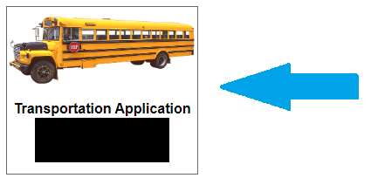
To set up the payment plan please close the current form and complete the Payment Plan Option Form, followed by the Transportation Application Payment Plan Form

- Complete the form including the Minimum Payment Option
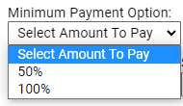

- Click submit.

- Click on the shopping cart.

- Submit payment.

- If the 50% minimum payment option was selected the remaining 50% remaining is automatically added to the account and must be paid prior to February 1, 2025.

