PowerSchool - Transportation Payment Plans
- Log into the PowerSchool Parent Portal
- Click on the link “Student Fees and Forms” in the sidebar navigation menu
- Select the student and click the “Transportation Payment Plan Option” form.
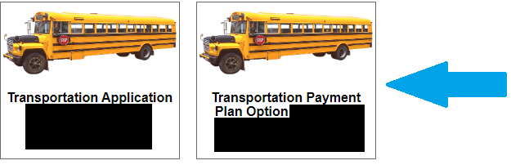
- Click the checkbox “Will Join Payment Plan” and submit form.
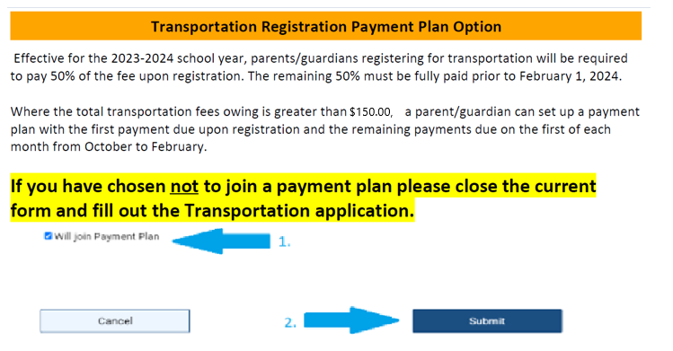
- Click the “Transportation Application Payment Plan”

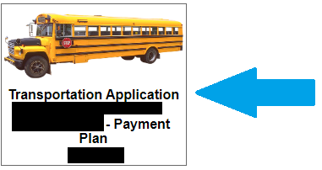
- Complete the form and select submit.

- Click on the shopping cart.

- Click Payment Plan

- Click “Managed Saved Cards” to add your payment information for the plan.
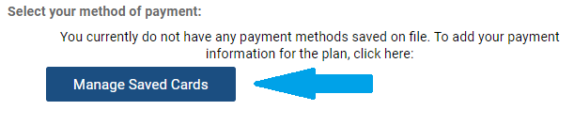

- Click Create Plan

- The Payment 1 is due upon registration. Return to the cart and complete the payment process.

